**Lesson 10: Coordinate Plane**

**Do Now:** Answer the questions below as best as you can. Be ready to explain how you used the graph to answer.

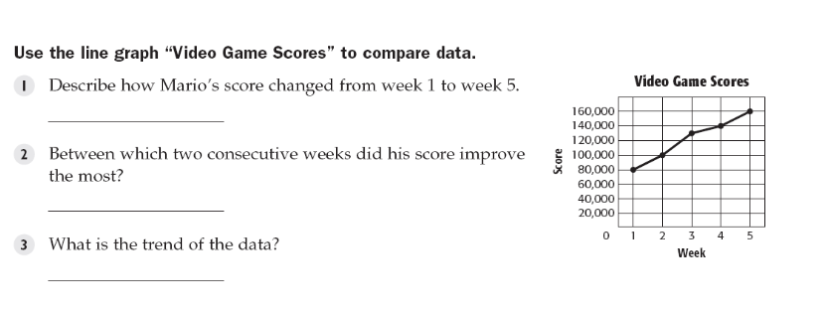

increasing by 80,000

2 and 3

increasing

(0,0)

(9,0) (9,-1)

(12, 1) (10,1)

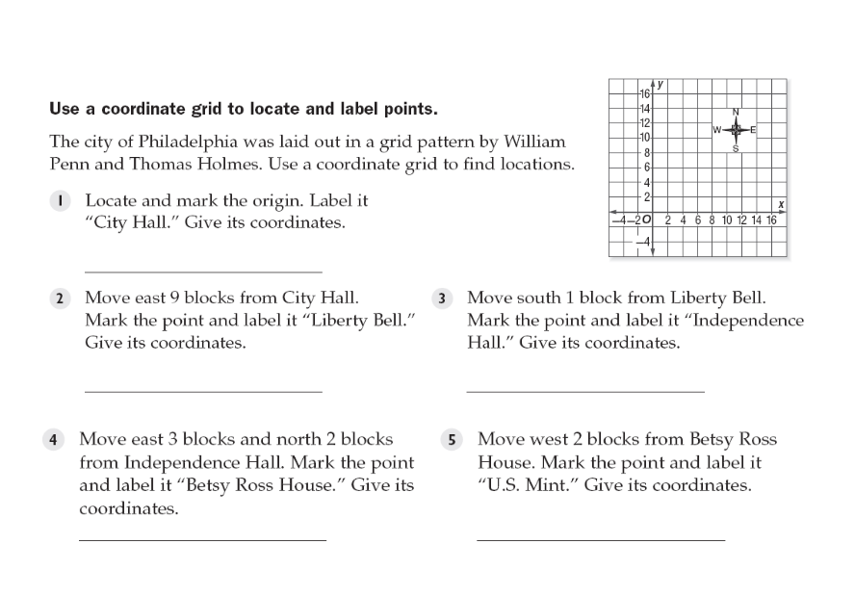

**Key Vocabulary:**

yes

no

yes

(1,4)

(-2,-2)

(3,0)

(1, -2)

(-3, 3)

x

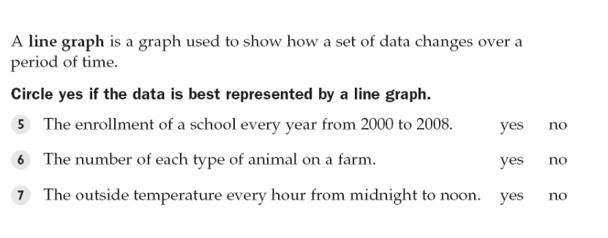

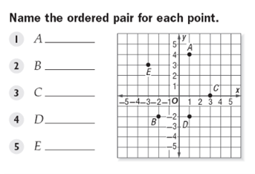

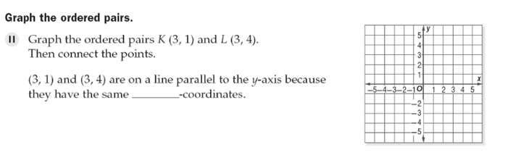

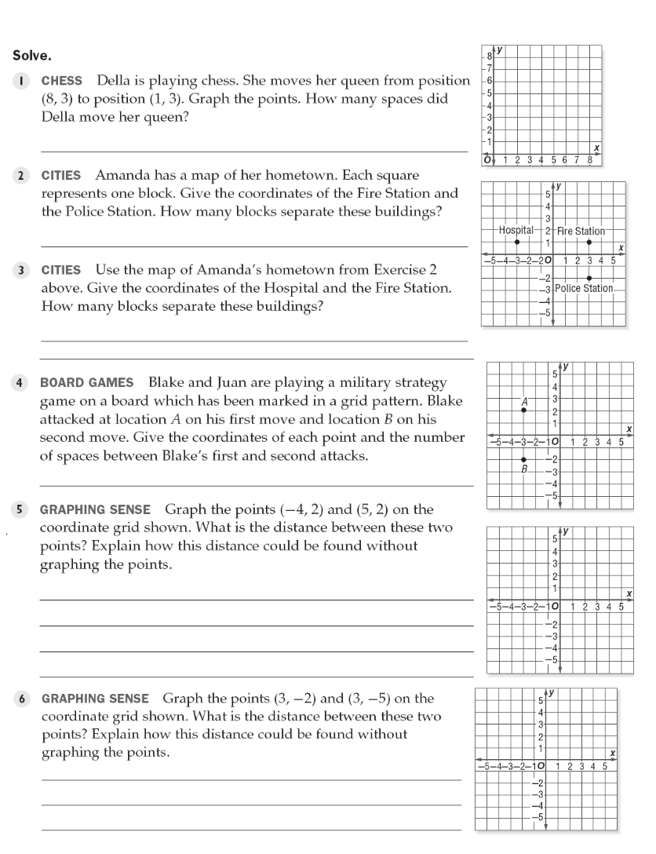 **Structured/Guided Practice:**

7

3

Hospital: (-3, 1) Fire Station: (3, 1); 6 blocks

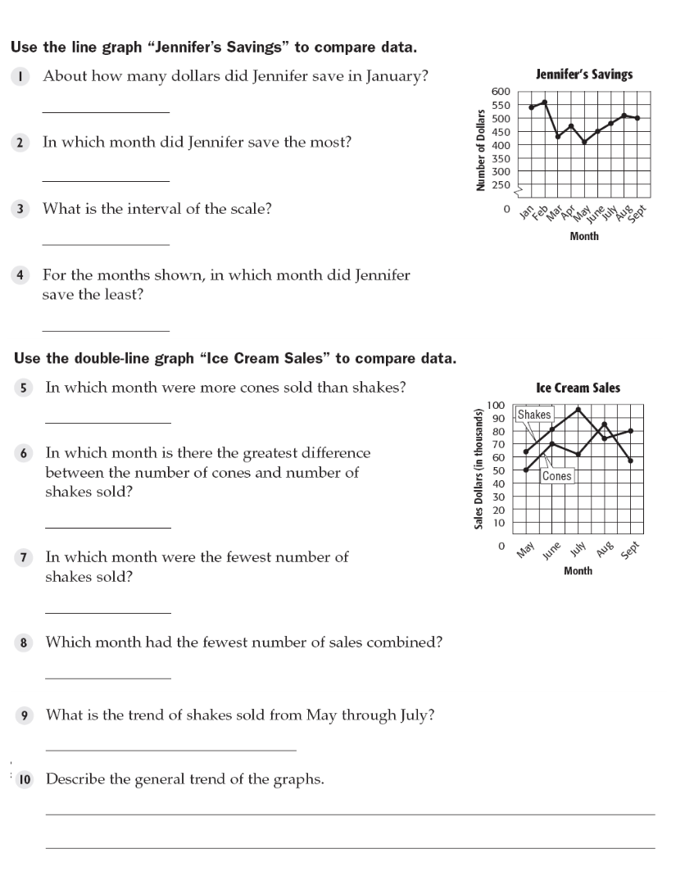

540

February

50

May

August

July

August

May

Increased but then decreased a bit

Both increased but decreased. Net increase

**Independent Practice:**

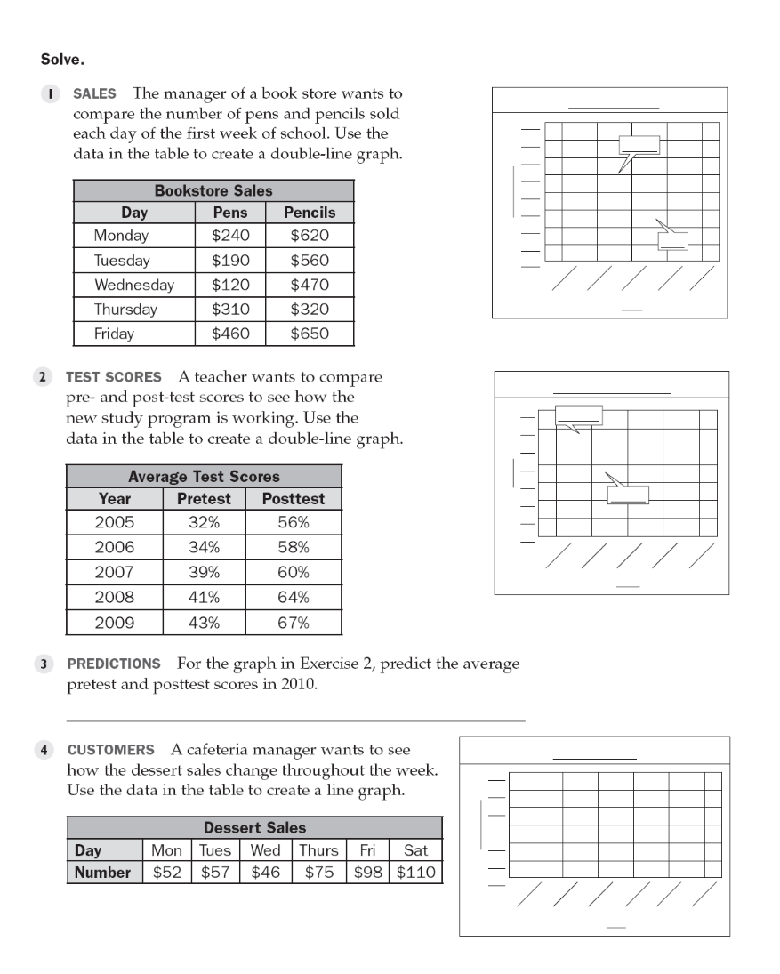

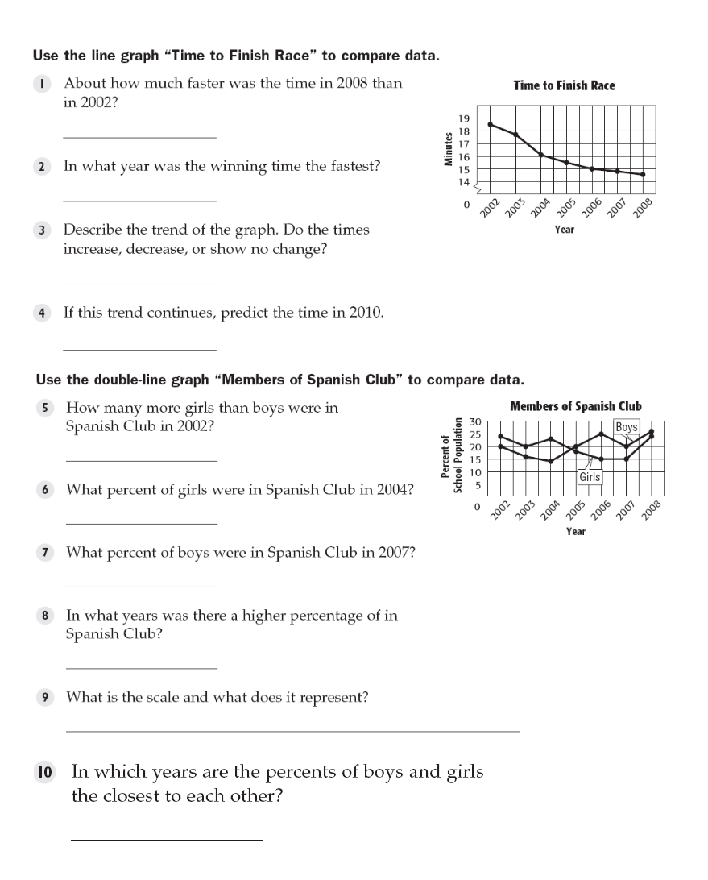

about 4 minutes

2008

decrease

14 minutes

5 percent more

15%

20%

2005 – 2008

0 – 30; Percent of school population

2005, 2008